# **Dream2space Cubesat Ground Station**

The Dream2space GUI Ground Station allows you to interact with your Dream2space Cubesat.

The Ground Station app is currently on available on Windows Operating System.

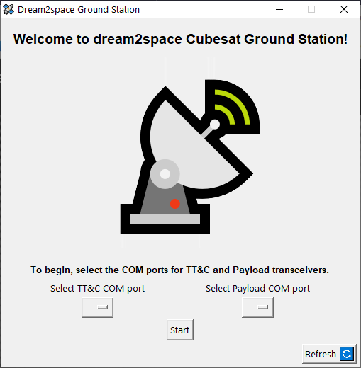

Table of Contents

Dream2space Cubesat Ground Station 1

Prerequisites 3

Step 1: Visit the Cygwin website 3

Step 2: Download Cygwin installer 3

Step 3: Install Cygwin 4

Getting Started 5

Step 1: Download the Ground Station app 5

Step 2: Setup the Ground Station transceivers 7

Step 3: Connect the TT&C transceiver to the computer 9

Step 4: Connect the Payload transceiver to the computer 10

Step 5: Open up the Ground Station app 11

Configuring the Ground Station 13

Step 1: Select the TT&C COM port 14

Step 2: Select the Payload COM port 16

Step 3: Confirm and Start running app 17

Ground Station Beacon Panel 18

Ground Station Housekeeping Data Panel 19

Step 1: Send the Housekeeping Command 19

Step 2: Navigate to location where logs are saved 22

Ground Station Mission Panel 23

Step 1: Open Mission Command window 23

Step 2: Fill in Mission Start date and time 24

Step 3: Fill in Mission images and interval 25

Step 4: Fill in Downlink Start date and time 26

Step 5: Send the Mission command 27

Step 6: Waiting for Mission to be executed 28

Step 7: Waiting for Downlink to be completed 29

Step 8: Viewing status of Missions 30

Step 9: Viewing Mission status and images 32

# **Prerequisites**

This step is needed if you are using a computer that runs on a **Windows** operating system.

The Ground Station app requires an additional software **Cygwin** to run.

## **Step 1: Visit the Cygwin website**

To download Cygwin, click the link [here](https://www.cygwin.com/).

Link to download Cygwin: <https://www.cygwin.com/>

The Cygwin page should look like this:

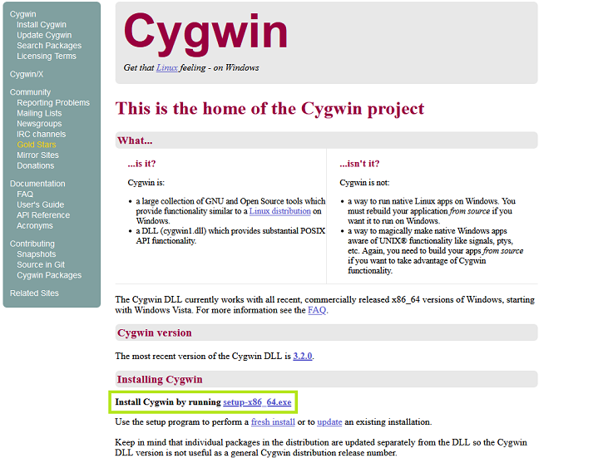

## **Step 2: Download Cygwin installer**

Click on the link setup-x86_64.exe to download the Cygwin installer, as shown in the **green** box in the screenshot above.

## **Step 3: Install Cygwin**

Proceed to install Cygwin using the installer.

When prompted to choose the Installation Directory, ensure that the Root Directory is C:\cygwin64.

The step and the correct Root Directory are shown in the **green** box in the screenshot below.

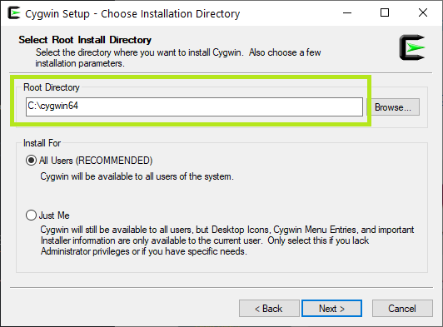

# **Getting Started**

## **Step 1: Download the Ground Station app**

To begin, download the Ground Station app.

Download the latest version of the Ground Station Ground_Station.exe from the Releases page [here](https://github.com/dream2space/dream2space-ground_station/releases/tag/v1.0).

Link to download Ground Station:

<https://github.com/dream2space/dream2space-ground_station/releases/tag/v1.0>

The Releases page should look like this:

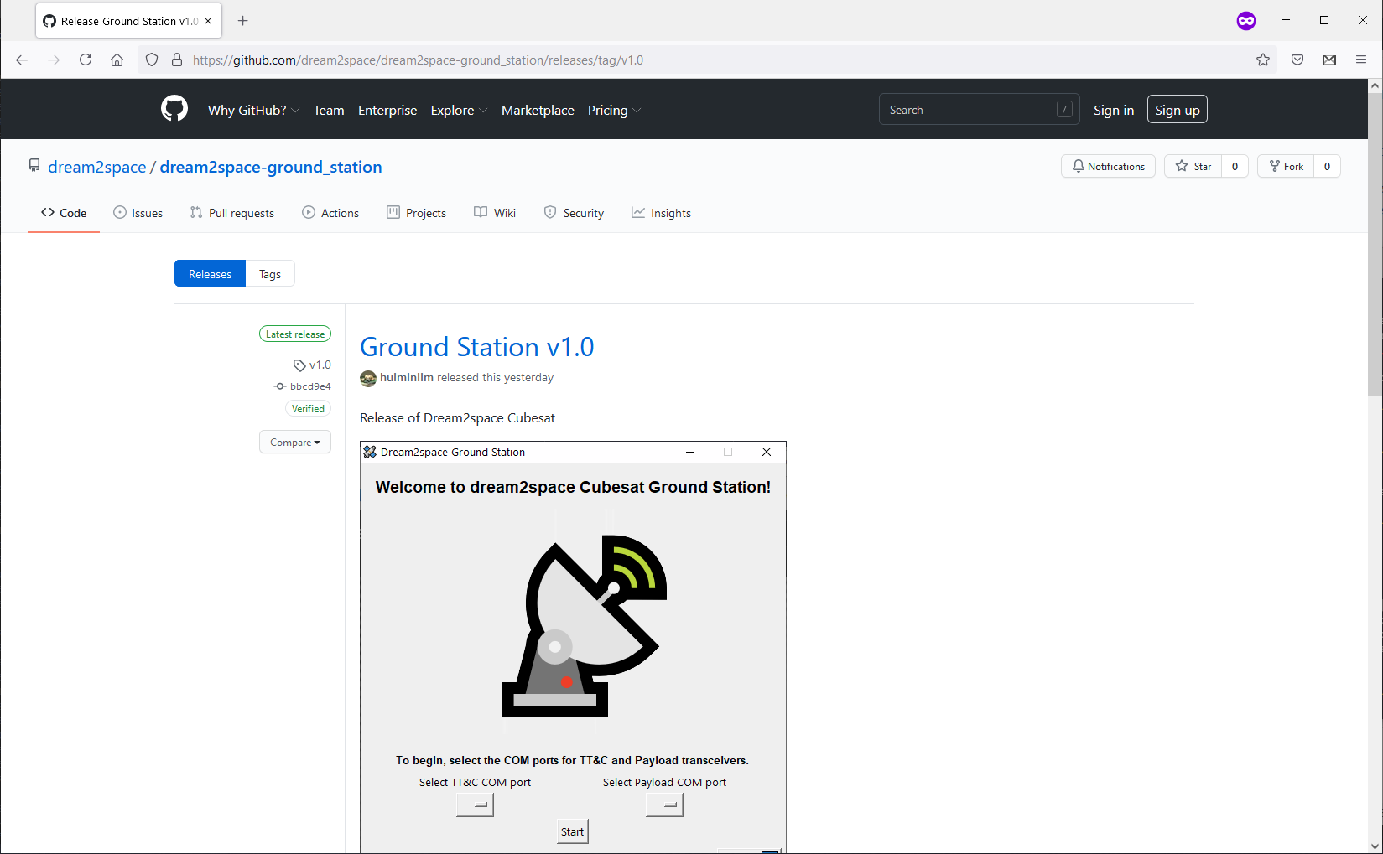

You can find the latest version of the Ground Station app and the Version tag in the table below.

|  |  |
| --- | --- |
| Executable Name | Version Number |
| Ground_Station.exe | v1.0 |

Scroll down to view the download link of the Ground_Station.exe app.

The download link of the Ground_Station.exe app is boxed in **green** box in the screenshot below.

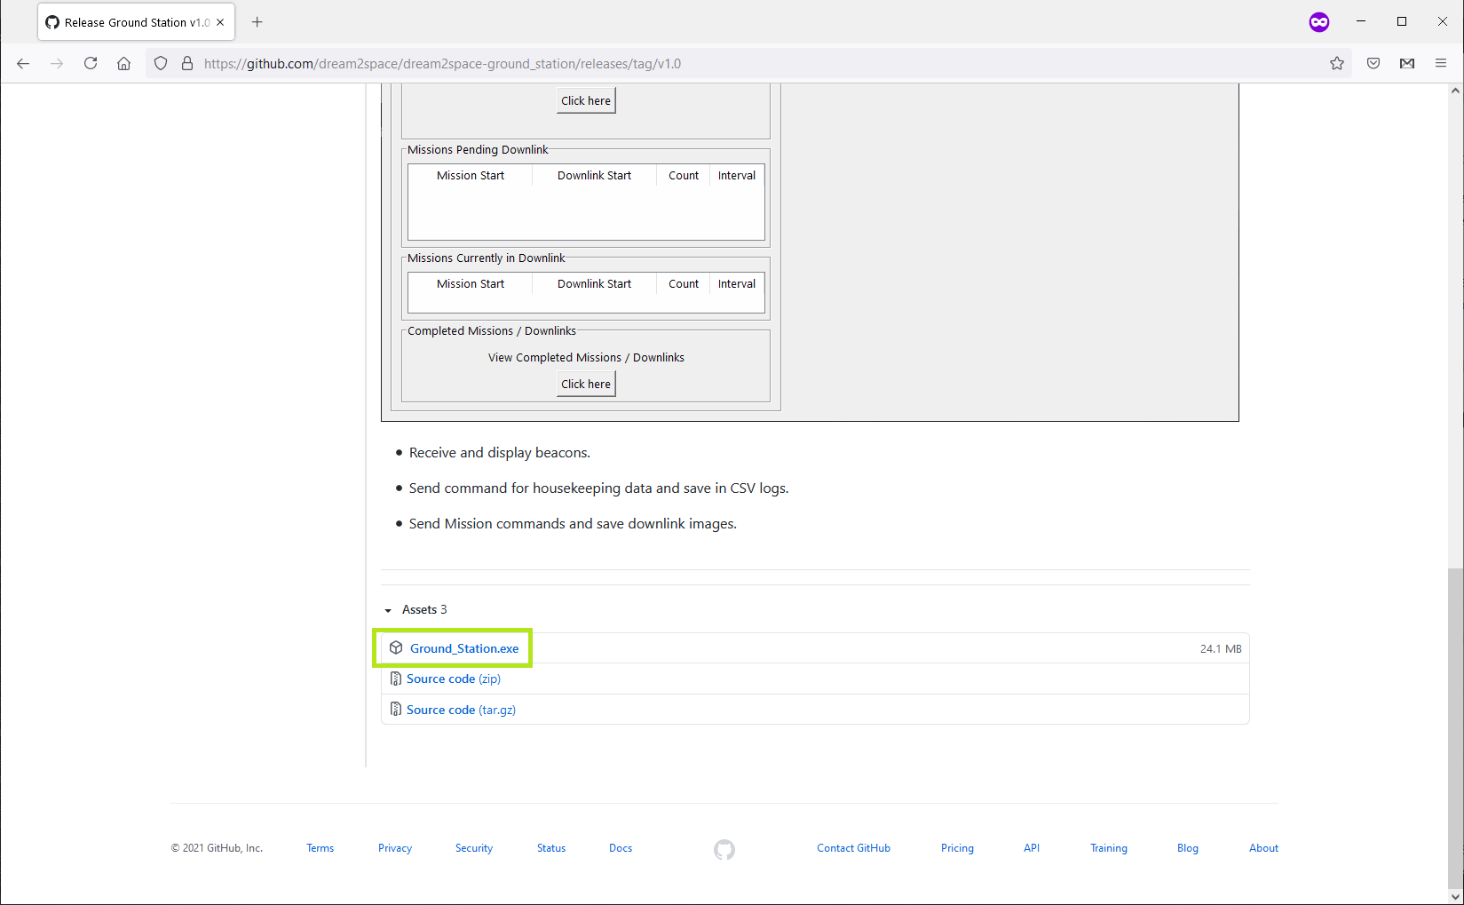

Click on the Ground_Station.exe under the **Assets** section to download it.

## **Step 2: Setup the Ground Station transceivers**

The Ground Station has two 433 MHz transceivers to communicate with the TT&C and the Payload of the Dream2space Cubesat respectively.

This is how a transceiver looks like:

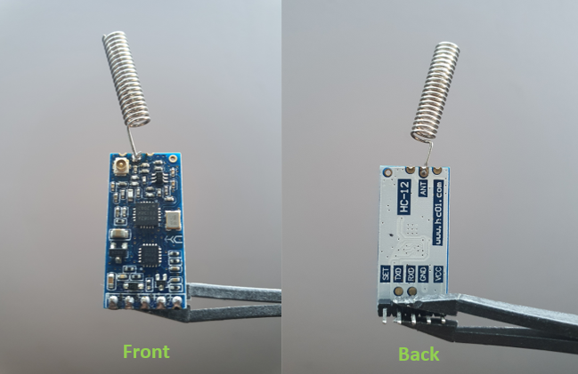

The transceiver uses the Universal asynchronous receiver-transmitter (UART) protocol to send data to and from the transceiver.

As most computers are unable to communicate via UART directly, a USB-UART bridge to connect the transceiver to the computer's USB ports.

This is how a USB-UART bridge looks like:

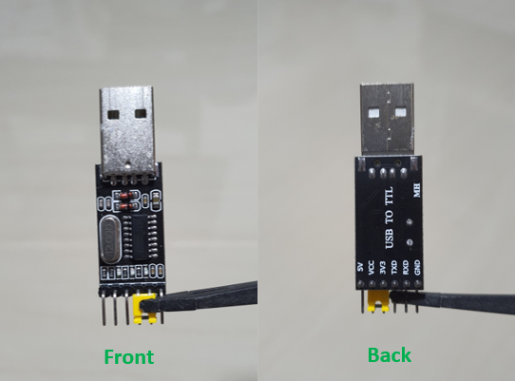

An example of the transceiver connected to the USB-UART bridge that you have received is shown below:

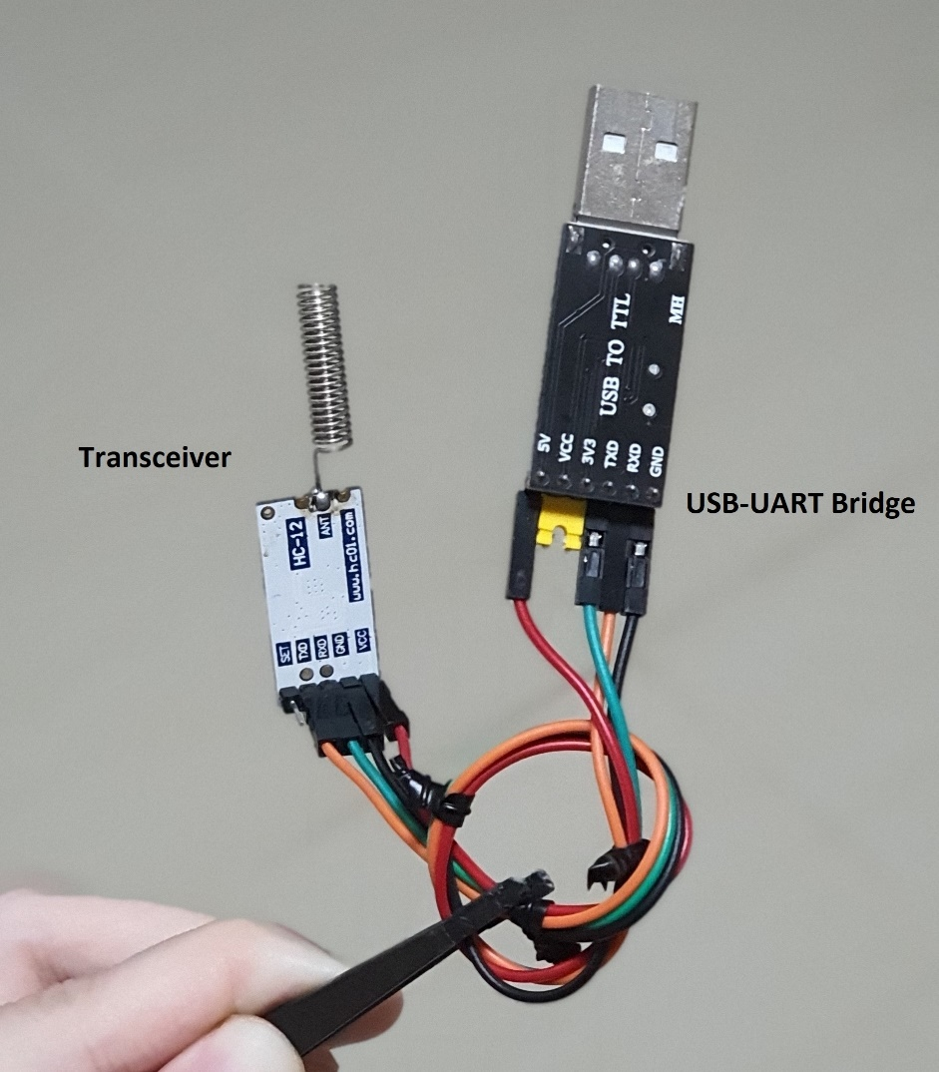

Double check that the pin connections are done as shown in the table below:

|  |  |
| --- | --- |
| USB-UART bridge | Transceiver |
| 5V | Vcc |
| GND | GND |
| TX | RX |
| RX | TX |

| **💡** | **This table is also a handy reference if the connections are removed by mistake!** |
| --- | --- |

## **Step 3: Connect the TT&C transceiver to the computer**

| **⚠️** | **The sequence of plugging in the USB-UART bridges is important.**  **Do try to follow the sequence.** |
| --- | --- |

The computer identifies the USB-UART bridges as virtual COM ports and each bridge is assigned a unique COM port number upon plugging in the USB.

The Ground Station app needs to know COM port number for the TT&C and Payload transceiver to read and write to the respective transceivers.

The TT&C transceiver comes with a label on the transceiver, as shown in the image below.

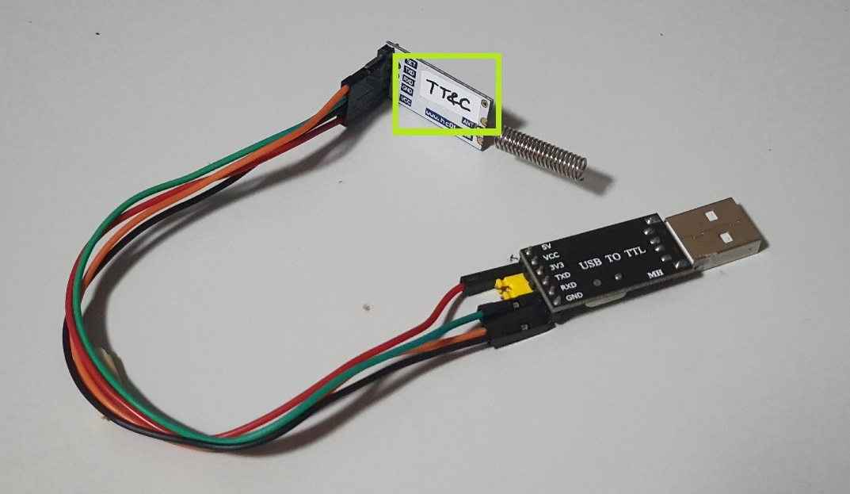

Plug in the TT&C transceiver's USB-UART bridge into the computer. The computer should detect the USB COM port and the COM port can be found using the Device Manager.

Note down the COM port for the TT&C transceiver's USB-UART bridge.

## **Step 4: Connect the Payload transceiver to the computer**

| **⚠️** | **The sequence of plugging in the USB-UART bridges is important.**  **Do try to follow the sequence.** |
| --- | --- |

The payload transceiver comes with a label on the transceiver, as shown in the image below.

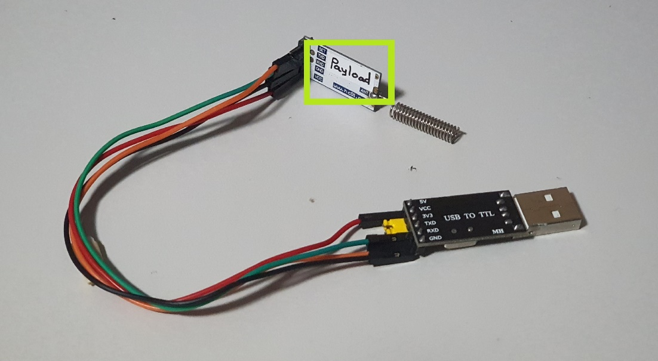

Plug in the Payload transceiver's USB-UART bridge into the computer. The computer should detect the USB COM port and the COM port can be found using the Device Manager.

Note down the COM port for the Payload transceiver's USB-UART bridge.

## **Step 5: Open up the Ground Station app**

| **⚠️** | **This is the recommended way to open up the GUI exe.**  **Other methods may cause errors.** |
| --- | --- |

Navigate to the folder containing the downloaded app, as shown in the folder below.

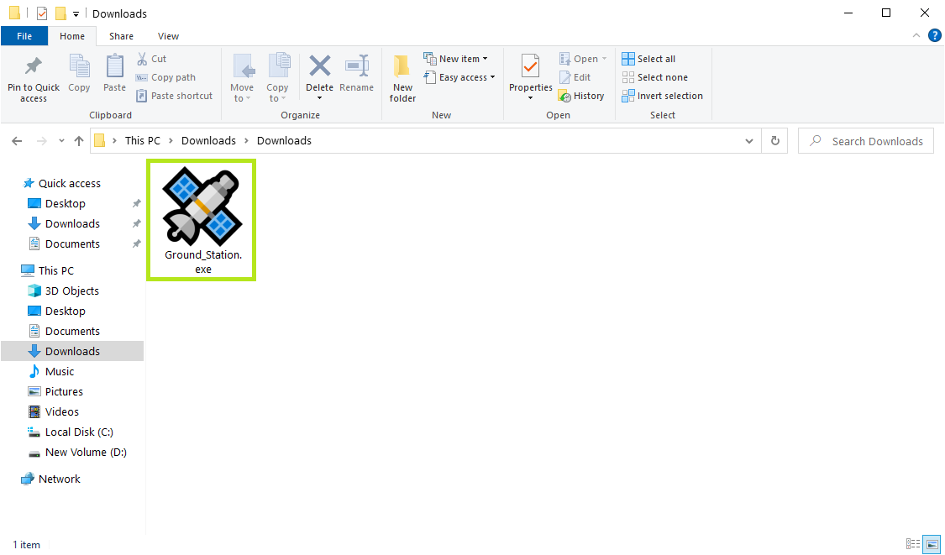

Double click on the icon to launch the app. The icon is boxed in **green** in the screenshot below.

If the app has launched successfully, the Start Page, as shown in screenshot below, will appear.



A dream2space folder will also be created in the same folder to store data collected from the app.

The folder is boxed in **green** in the screenshot below.

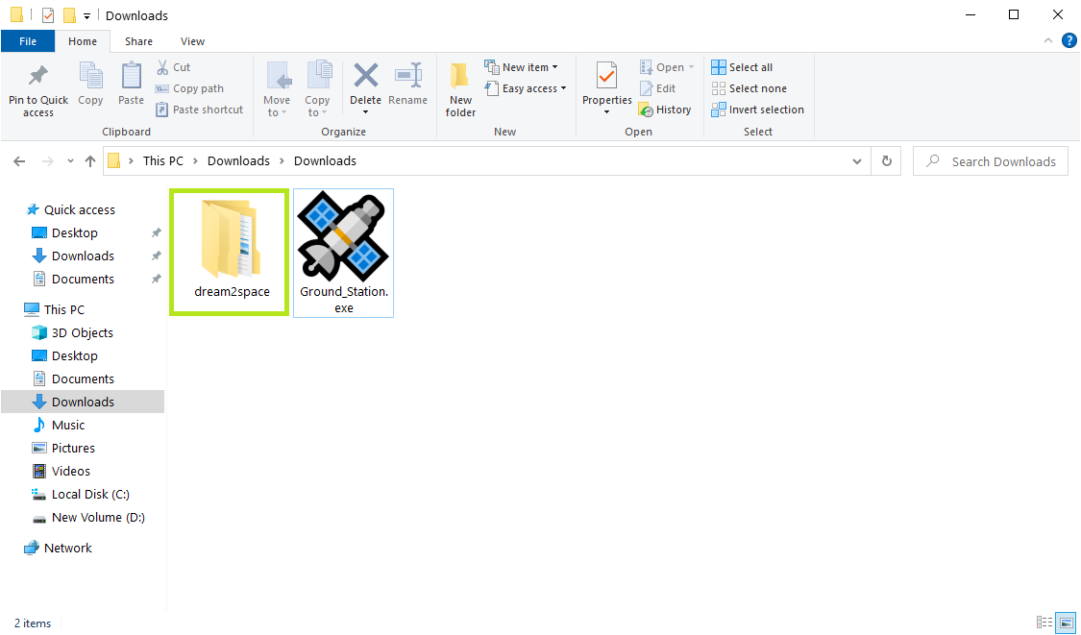

| **⚠️** | **Do not delete that folder while the app is running!** |
| --- | --- |

# **Configuring the Ground Station**

| **💡** | **TIP!** |
| --- | --- |

If you cannot spot the COM ports noted down in previous steps, try clicking on the Refresh button.

The Refresh button is boxed in **green** in the screenshot below.

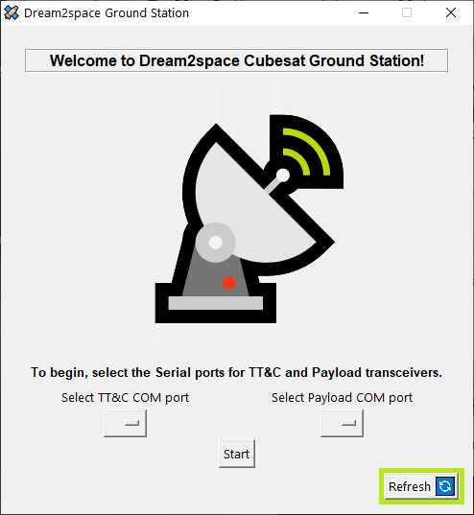

The Refresh button will scan and reload the available COM ports again.

## **Step 1: Select the TT&C COM port**

To view the list of COM ports available for selection as the TT&C transceiver's port, click on the dropdown menu.

The dropdown menu is boxed in **green** in the screenshot below.

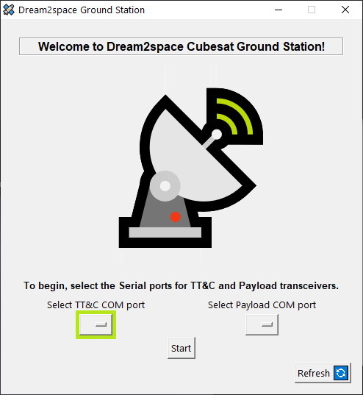

The list of discovered COM ports will be displayed.

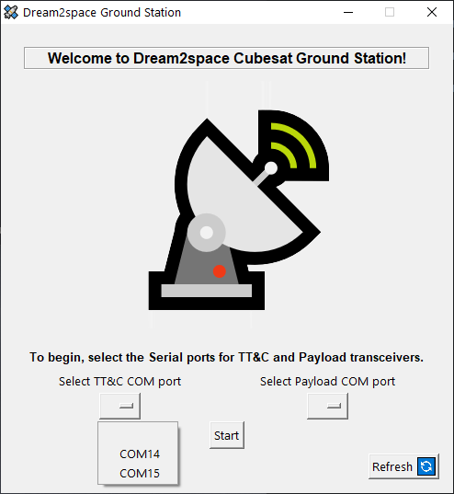

Select the COM port that you have noted down after plugging in the TT&C transceiver's USB-UART bridge.

## **Step 2: Select the Payload COM port**

To view the list of COM ports available for selection as the Payload transceiver's port, click on the dropdown menu.

The dropdown menu is boxed in **green** in the screenshot below.

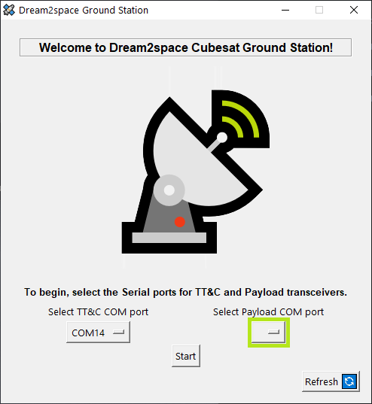

The list of discovered COM ports will be displayed.

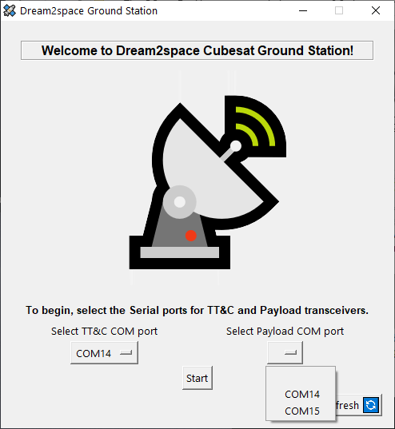

Select the COM port that you have noted down after plugging in the Payload transceiver's USB-UART bridge.

## **Step 3: Confirm and Start running app**

After selecting COM ports for the TT&C and Payload transceivers, click on the Start button to proceed.

The Start button is boxed in **green** in the screenshot below.

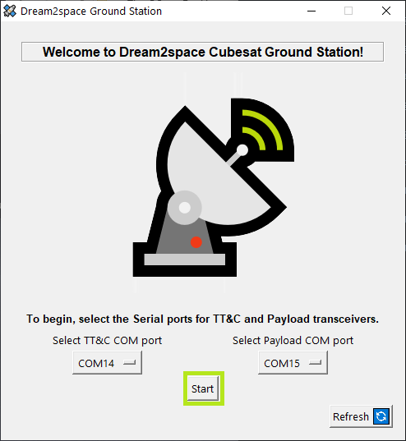

After which, the app will display the Ground Station main page as shown below.

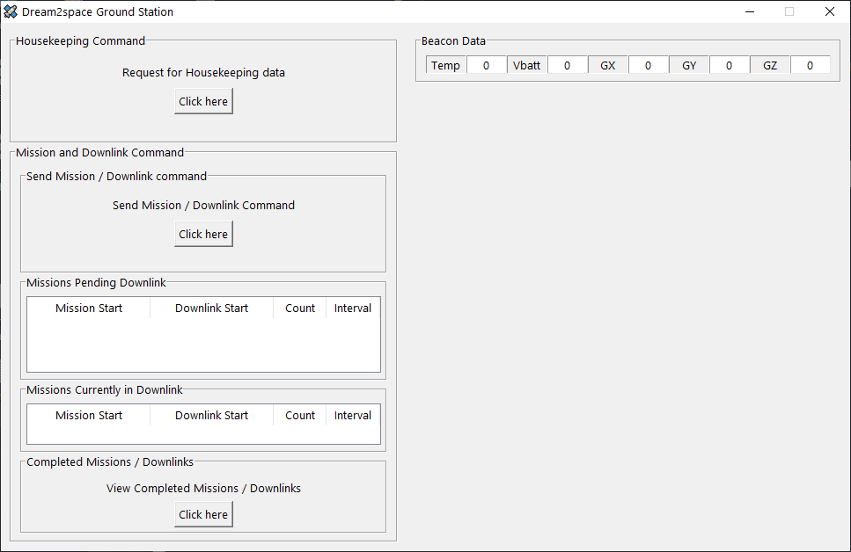

# **Ground Station Beacon Panel**

Every minute, the Dream2space Cubesat will send beacons to advertise its presence.

The Ground Station will pick up the beacons to display it in the Beacon panel of the Ground Station.

The Beacon panel is boxed in **green** in the screenshot below.

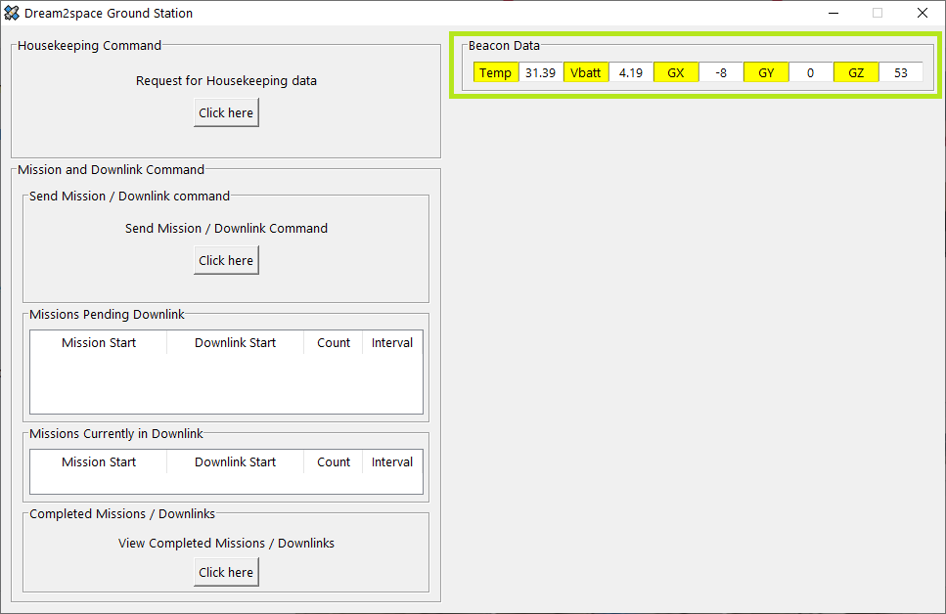

The Beacon panel display will blink in **yellow** to indicate a new beacon has arrived in the Ground Station.

# **Ground Station Housekeeping Data Panel**

The Ground Station is capable of sending commands to the Dream2space Cubesat to retrieve housekeeping data stored onboard.

Housekeeping data refers to sensor data collected by the On-board Computer (OBC).

The steps below show how to retrieve housekeeping data from the Dream2space Cubesat.

## **Step 1: Send the Housekeeping Command**

To send a housekeeping command, click on the button to request for housekeeping data.

The button is boxed in **green** in the screenshot below.

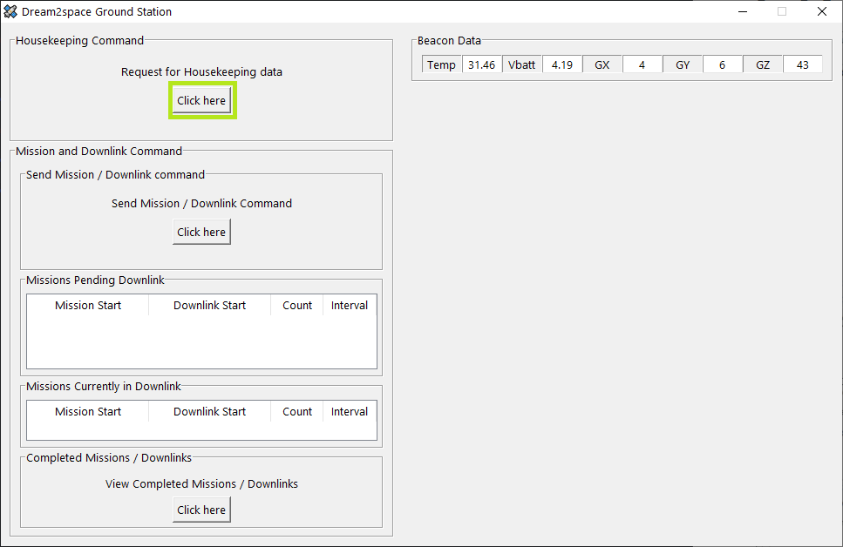

After the Housekeeping command request button is clicked, the housekeeping command will be sent to the Dream2space Cubesat.

While the command is being sent, the progress bar will be shown.

To ensure that the housekeeping command is sent without disruption, all commands sending will be disabled.

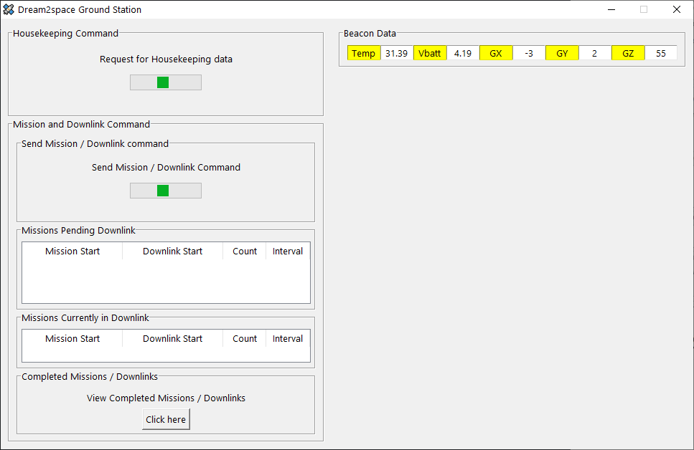

Once the Ground Station receives a response from the Dream2space Cubesat **successfully** (after approximately 5 seconds), the Housekeeping Data panel will indicate with a success message.

Upon seeing the success message, proceed to Step 2.

The success message is boxed in **green** in the screenshot below.

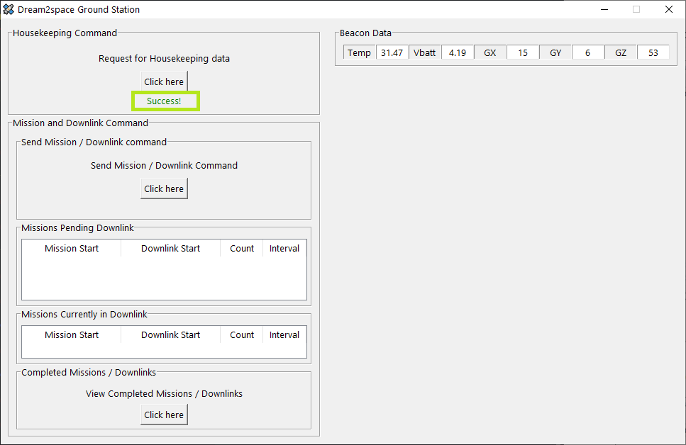

If the progress bar still appears after 10 seconds, the operation is likely to have failed and an error message will be shown.

The error message is boxed in **red** in the screenshot below.

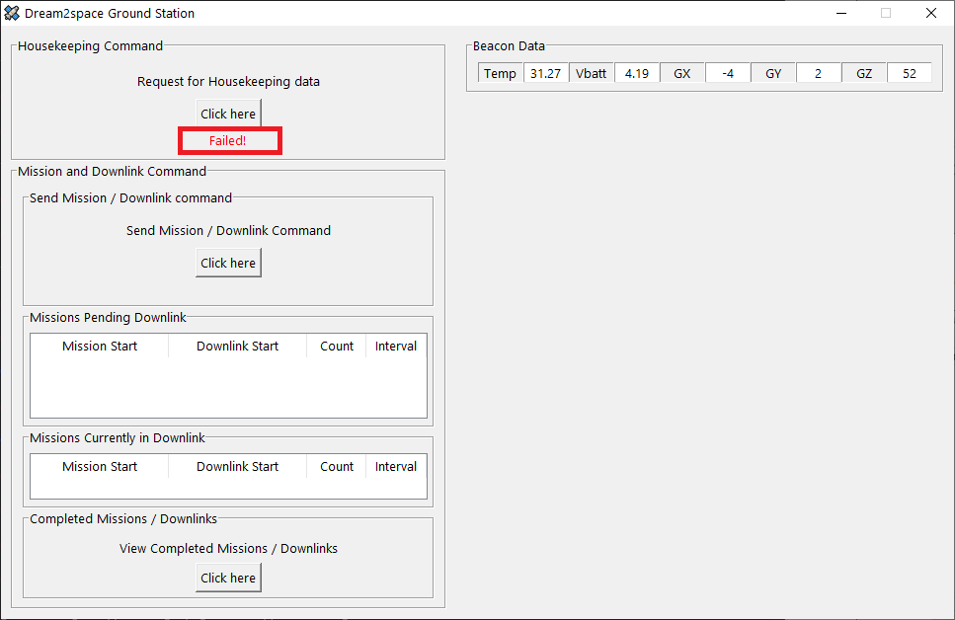

To retrieve housekeeping data, send the housekeeping command as described in Step 1.

## **Step 2: Navigate to location where logs are saved**

After the response containing housekeeping data is successfully received by the Ground Station, the Ground Station will process, save into Comma Separated Values (CSV) log files and pop up the Explorer window showing the folder containing the CSV file.

The CSV file is saved in the dream2space/housekeeping_data folder.

For instance, the screenshot below shows the Explorer window popped up after a successful housekeeping data retrieval operation.

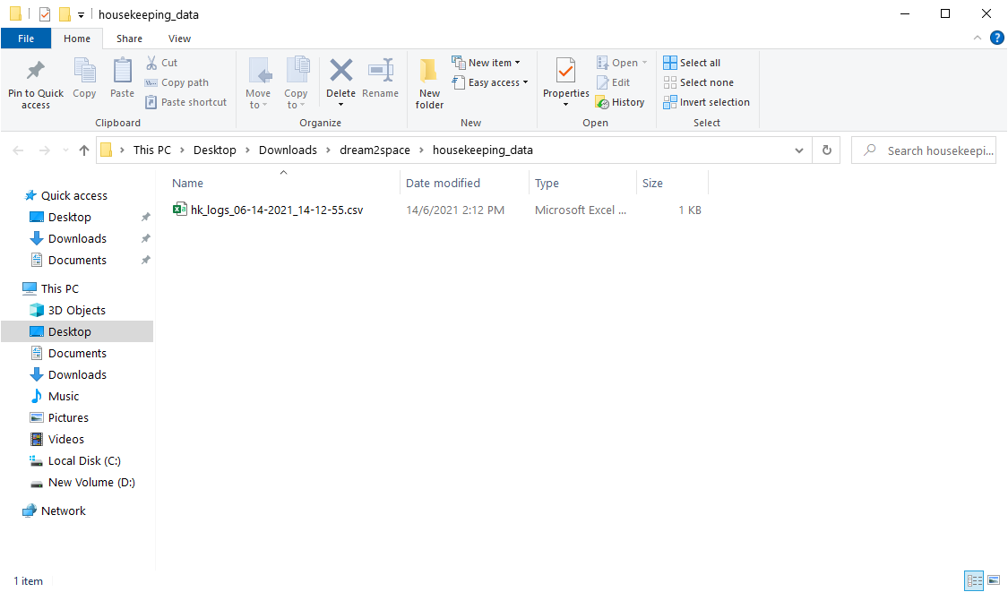

Click on the CSV file and the CSV file will contain the housekeeping data received, as shown in the screenshot below.

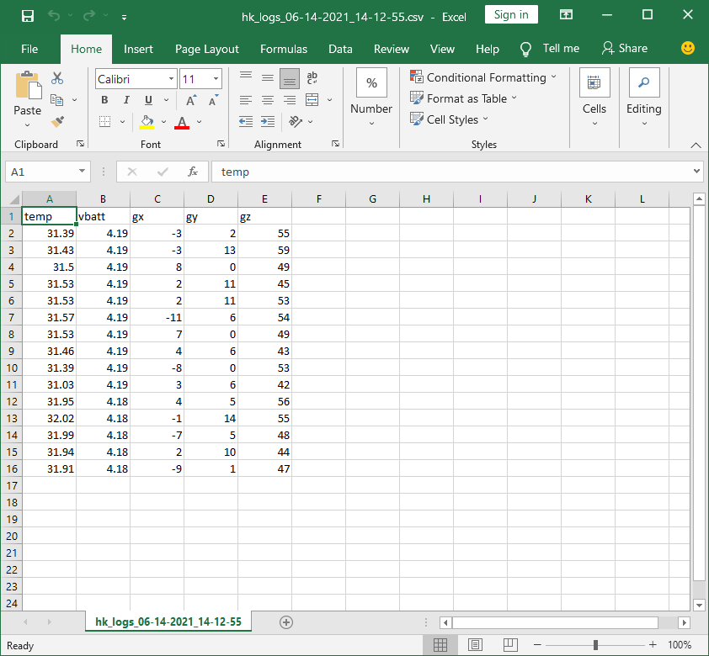

# **Ground Station Mission Panel**

The Ground Station is capable of sending Mission commands to the Dream2space Cubesat to capture images and transmitting them down to the Ground Station for storage.

The steps below show how to send a Mission command and receive images via downlink from the Dream2space Cubesat.

## **Step 1: Open Mission Command window**

Click on the button to send a Mission/Downlink command.

The button is boxed in **green** in the screenshot below.

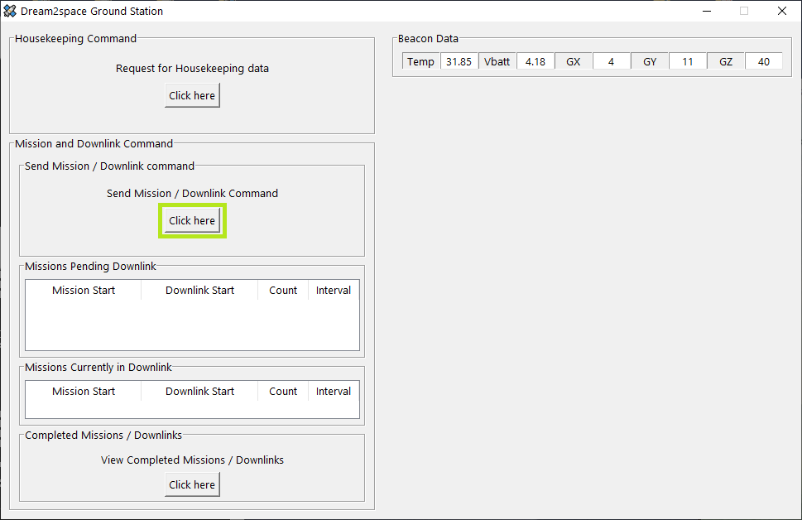

A Mission command window will pop up, as shown in the screenshot below.

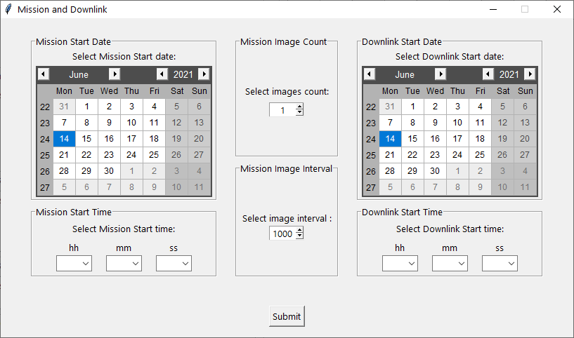

## **Step 2: Fill in Mission Start date and time**

Fill in the Mission Start date and time in the Mission Start Date and Mission Start Time panels.

There are some rules that the Mission Start date and time needs to adhere to:

1. The Mission Start date and time must be in the future.
2. It is recommended to be at least 2 minutes from the current time.
3. The Mission Start time must not be less than 15 seconds before or after an already scheduled Mission.
4. There can only be at most 3 incomplete missions at any time.

The Mission Start Date and Mission Start Time panels are boxed in **green** in the screenshot below.

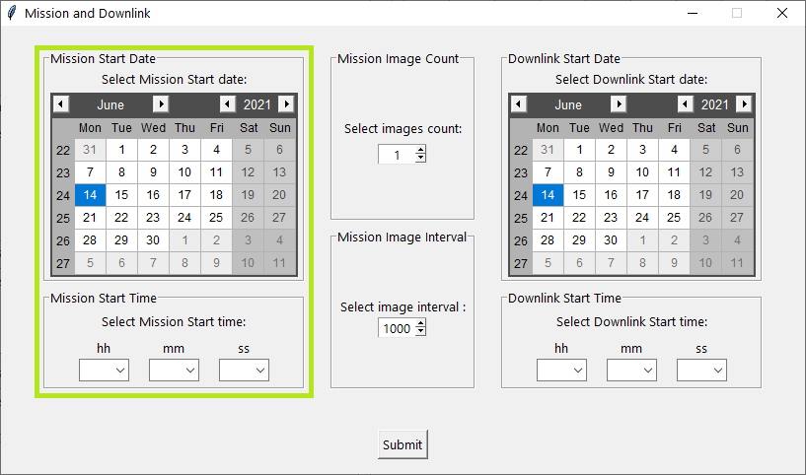

## **Step 3: Fill in Mission images and interval**

Fill in the number of images to be taken in the mission in the Mission Image Count panel and the interval between each image in the Mission Image Interval panel.

The Mission Image Count and Mission Image Interval panels are boxed in **green** in the screenshot below.

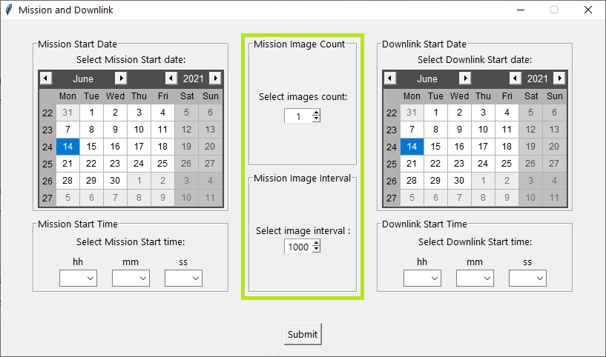

In each field, there are some allowed values that these mission parameters can take.

Use the arrows to select the values to input for each mission parameter.

The table below shows the values allowed for the Mission Image Count and the Mission Image Interval field.

|  |  |  |  |
| --- | --- | --- | --- |
| Field | Units | Min | Max |
| Mission Image Count | N/A | 1 | 3 |
| Mission Image Interval | ms | 1000 | 5000 |

## **Step 4: Fill in Downlink Start date and time**

Fill in the Downlink Start date and time in the Downlink Start Date and Downlink Start Time panels.

There are some rules that the Downlink Start date and time needs to adhere to:

1. The Downlink Start date and time must be in the future.
2. The Downlink Start date and time must be after the Mission Start date and time.
3. The Downlink Start date and time must not be less than 10 minutes before or after an already scheduled Downlink.

The Downlink Start Date and Downlink Start Time panels are boxed in **green** in the screenshot below.

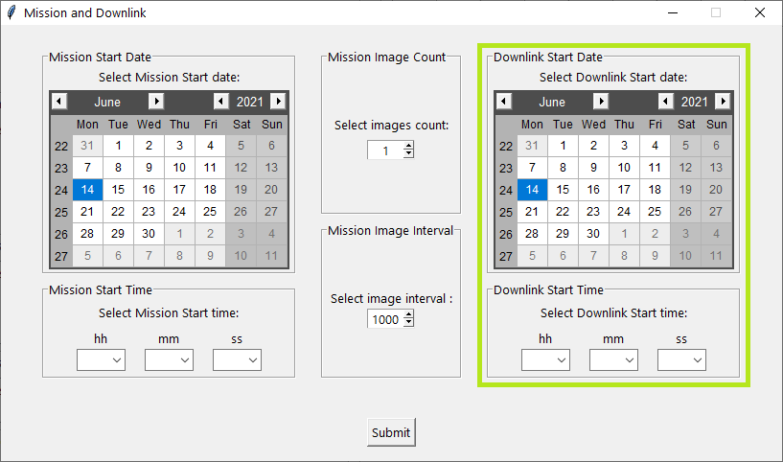

## **Step 5: Send the Mission command**

To send the mission command, click on the Submit button.

The Submit button is boxed in **green** in the screenshot below.

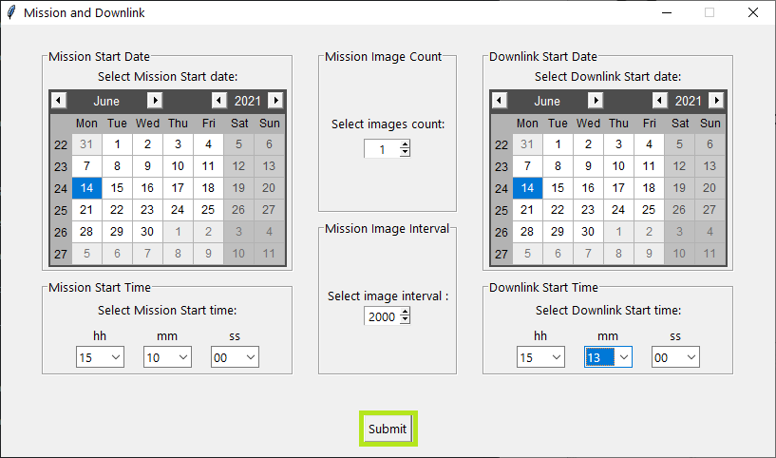

## **Step 6: Waiting for Mission to be executed**

After the Submit button is clicked, the command will be sent to the Dream2space Cubesat.

While the command is being sent, the progress bar will be shown.

To ensure that the housekeeping command is sent without disruption, all commands sending will be disabled.

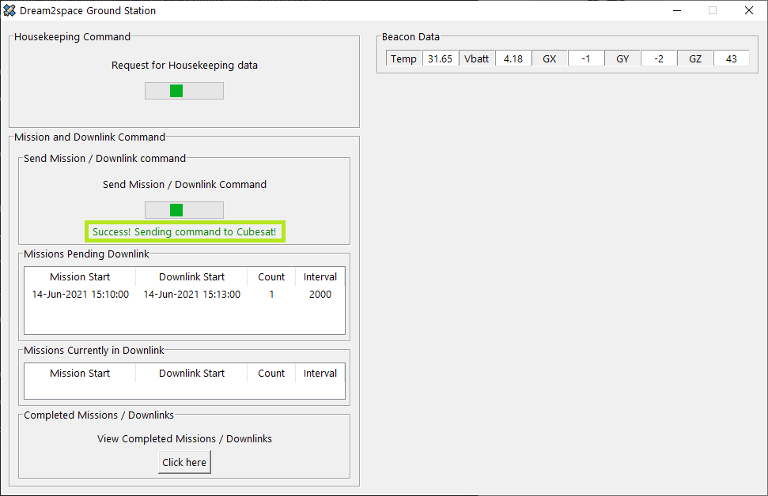

After the mission command is sent, a mission record is kept in the Missions Pending Downlink panel.

The record will be stored here until 2 minutes before the Downlink time of the Mission.

An example of a mission record in the Missions Pending Downlink panel is boxed in **green** in the screenshot below.

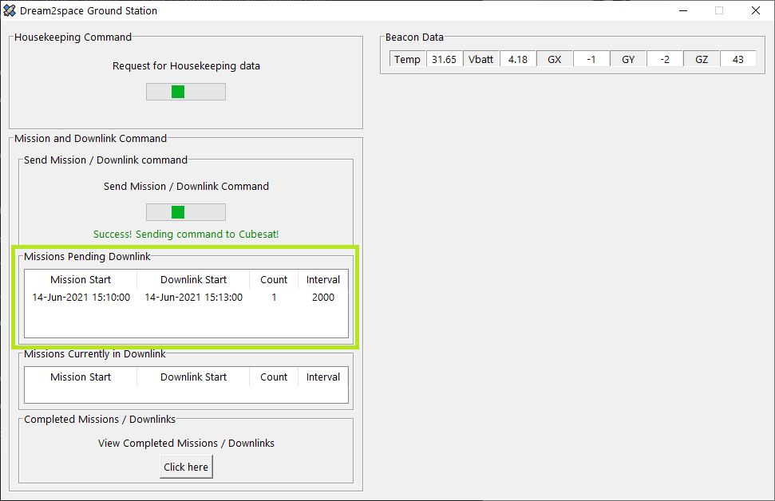

## **Step 7: Waiting for Downlink to be completed**

When a mission is 2 minutes away from its Downlink time, the Ground Station will enter standby mode to wait for the downlink of images.

When this happens, the mission record will be shifted from the Missions Pending Downlink panel to the Missions Currently in Downlink panel.

An example of a mission record in the Missions Currently in Downlink panel is boxed in **green** in the screenshot below.

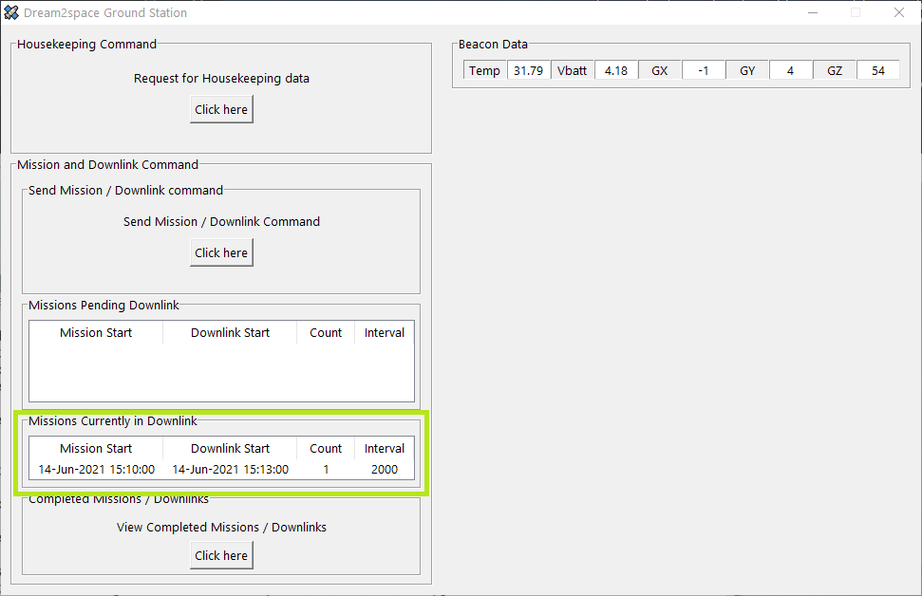

The mission record will remain there until the completion of downlink, error correction and decoding and of images collected (if successful).

## **Step 8: Viewing status of Missions**

After the completion of downlink, the mission record will be removed from the Missions Currently in Downlink panel.

To view the overall status of the mission, click on the button to view completed mission/downlink operations.

The button is boxed in **green** in the screenshot below.

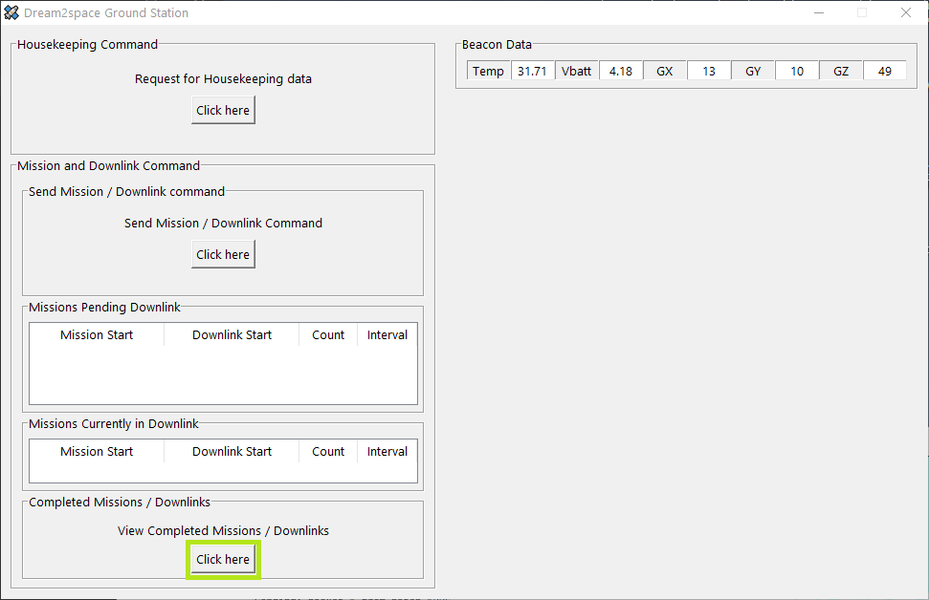

Clicking on the button opens up a CSV file containing the status records of all missions executed.

The table below describes what it means for an operation to be successful or have failed:

| **Status** | **Meaning** |
| --- | --- |
| SUCCESS | All the process (Downlink, Error correction with Reed-Solomon, Decoding/Processing of images) are completed successfully. |
| FAILED | One of the above-mentioned processes have failed. |

The screenshot below shows an example if the status if the mission was successful.

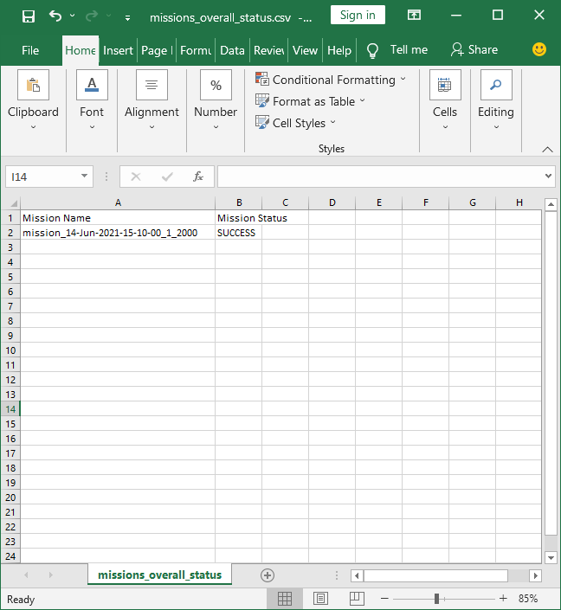

The screenshot below shows an example if the status if the mission has failed.

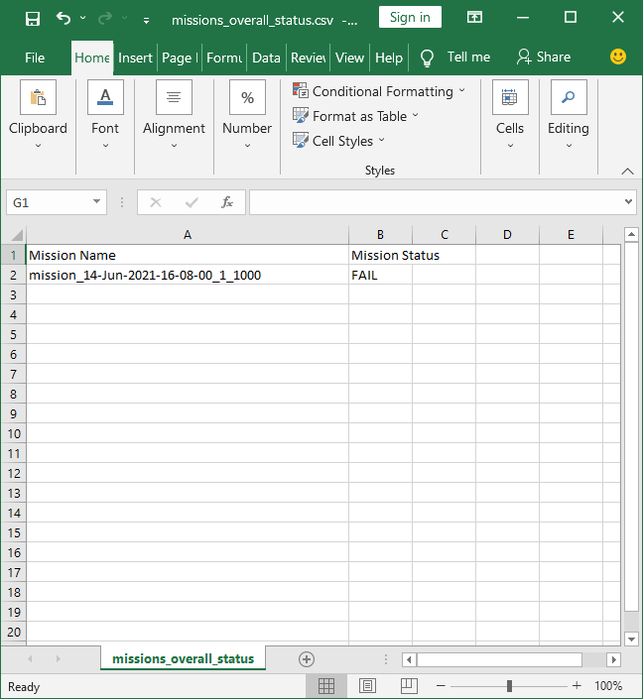

## **Step 9: Viewing Mission status and images**

Clicking on the button also opens up an explorer to view the list of folders where mission images are stored in.

Click on the folder containing the executed mission to view the contents.

For example, the folder with the mission previously executed is boxed in **green** in the screenshot below.

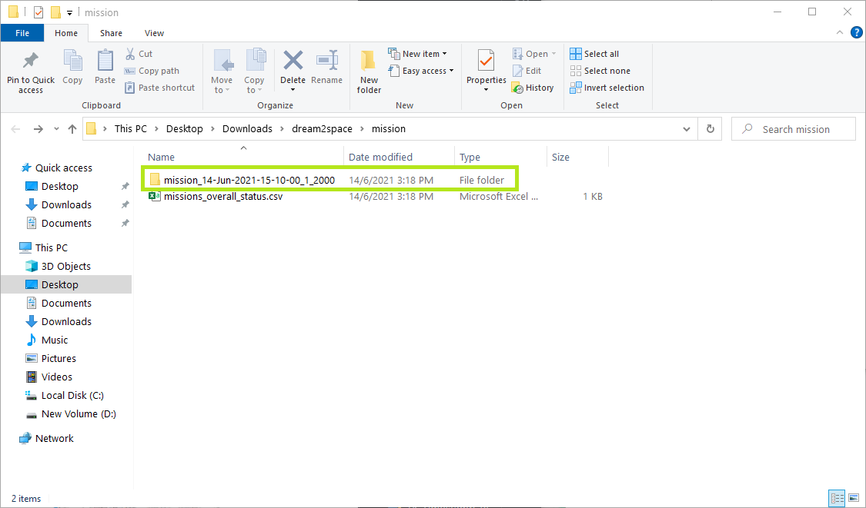

If the mission was successful, the recovered images will be found in the folder.

A text file log of the detailed mission status will also be found in the folder.

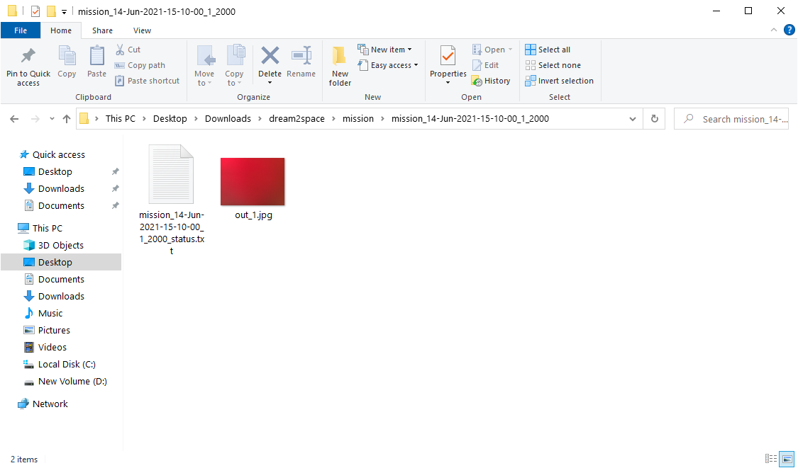

Opening the text log file will show the status of each process that the Ground Station undertakes to receive, perform error correction and decode the image.

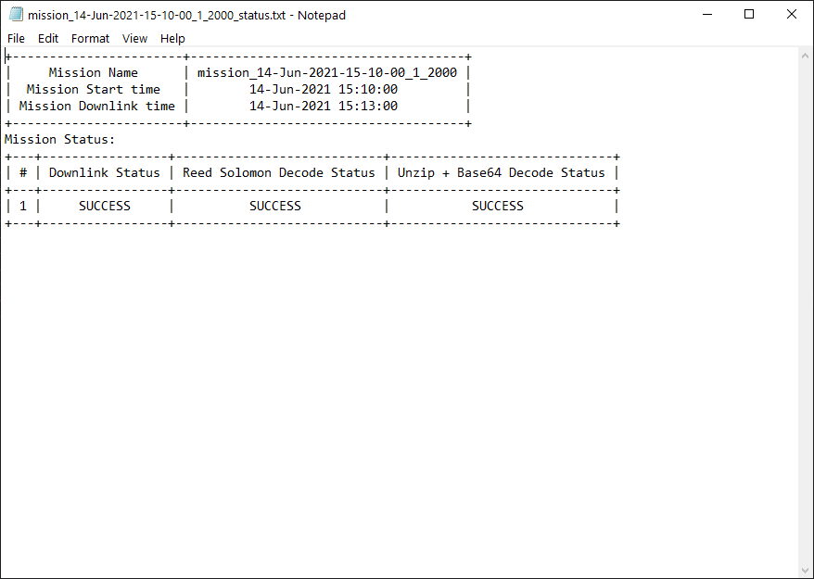

This is important in the scenario to find out what is wrong in the downlink process.

For example, the logs below show that the decoding of the images using Base64 has failed.

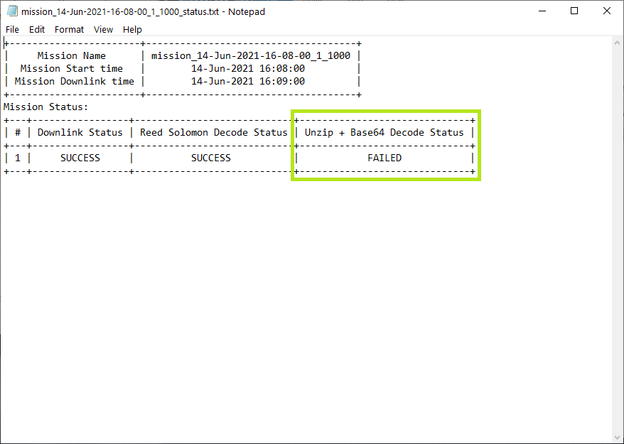

This is useful for debugging and troubleshooting the connections and transmission between the Cubesat and the Ground Station.